Pittsburgh Anti-Sweatshop Community Alliance - PASCA
AllStar Civil Rights Calendar

Saturday June 3rd at 12 PM - Conference for Immigrants’ Rights at the First Lutheran Church at 615 Grant St. We join Pittsburgh Friends of Immigrants in saying, “No Human Being Is Illegal!” Everyone is welcome in the City of Champions!

Tuesday June 6th at 7 PM - Meeting with organizers of the United Workers Association of Baltimore and All Star action planning at the Friends Meeting House - 4836 Ellsworth Avenue - 71C bus from town

Tuesdays June 20th AND 27th at 7 PM - Sweatshop Carnival preparations: “Toss That Worker a Peanut,” “The Wheel of Wages,” “Close This Factory,” “Baseball for Workers,” and a “No Sweatshop Bucco!” Pirate mural coloring contest. Both meetings will also be held at the Friends Meeting House.

Tuesday July 4th - DIRECT ACTION MEETING at the Roberto Clemente Statue 45 minutes before fireworks are scheduled to begin
PNC PARK JUMBOTRON
ALLSTAR SWEATSHOP

July 11th, 2006 at 5 PM - Gather at Freedom Corner (Centre and Crawford Avenues) where we heard testimony from the National Garment Workers Federation of Bangladesh

July 11th, 2006 at 6 PM - Begin our Sweatshop Carnival on Roberto Clemente Bridge and around PNC Park. We’ll continue throughout the game and late into the evening. Come early. Stay late.

NOTE: Plans for the All Star Sweatshop Activities are adapting every day.

Sunday October 22nd - 11th Annual National Day of Protest to Stop Police Brutality at Freedom Corner

FREE SPEECH and SAFETY at the ALLSTAR GAME
We have an absolute commitment to both safety and free speech. Thank you Elizabeth Pittinger of the Civilian Police Review Board for helping to maintain an open dialogue with the Pittsburgh Police Department and the All Star security team. Vic Walczak, PA Legal Director of the ACLU, and Mike Healey of the National Lawyers Guild help us exercise our rights here in Pittsburgh.

CHECK HERE FOR UPDATES: www.iww.org/unions/iu410/mlb/
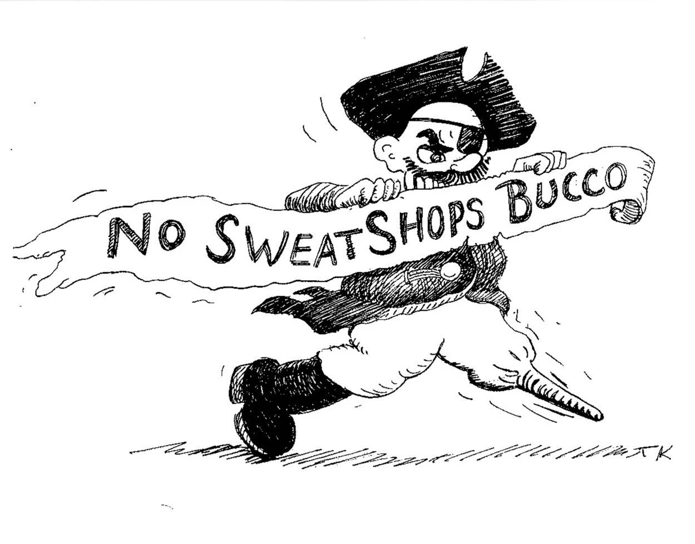
ALLSTAR 2006

The ANTI-SWEATSHOP
Pirates of Pittsburgh
Will Commandeer
Roberto Clemente Bridge
July 11th, 2006

Inside: Who sews our Pirates logo?
Are you an Anti-Sweatshop Pirate?
What is the Multi-Fiber Arrangement?
What can the Pittsburgh Pirates do to stop sweatshops?
Who Sews Our Pirates and All Star Logo Apparel?

90% of workers sewing Pirates and All Star logo apparel are high school and college age women. In many cases they are the only wage earners in their family.

They are a lot like our friends and family members. They want to live in safe and clean communities. They want educational opportunities and a life when the workday is through. They have HUMAN RIGHTS that deserve to be protected. In a world of law, people should not have to choose between working in a sweatshop and having no job at all.

The facts of their employment are undeniable:

- POVERTY WAGES – far below subsistence levels in whatever country they are in
- EXTREME FORCED overtime
- UNSAFE WORKING CONDITIONS - factory fires and extreme repetitive motion injuries
- MANDATORY pregnancy tests, firings for pregnancy, and other violations of women’s rights
- FIRED and BLACKLISTED for trying to organize unions

The Anti-Sweatshop Pirates of Pittsburgh have accumulated testimony from workers sewing Pirates and All Star logo apparel and will be happy to work with credible investigators and reporters.

Major League Baseball and most of the licensers of the baseball products deny reasonable knowledge of these working conditions, but the Anti-Sweatshop Pirates of Pittsburgh have brought the workers’ testimony to PNC Park and the workers are here with us at the All Star Game.

We know that HUMAN RIGHTS are being violated in these factories. Major League Baseball, the labels, and their contractors are playing an accountability shell game with peoples’ lives. What matters is that the Anti-Sweatshop Pirates of Pittsburgh have a relationship with the workers who sew our Pirates and All Star logo apparel and we are using their testimony to build a Civil Rights Bridge between PNC Park and the floor of the Global Sweatshop.
Why Sports and Why Baseball?

Through sports we express our values and rejoice in human potential. In the same way South Africa was expelled from the Olympic Games in 1970, we can use the Pittsburgh Pirates Baseball Club and our affection for our City and our teams’ logo to raise standards in the global apparel industry. The Pittsburgh Pirates have more fans attending games each season than all of the other sports combined, and PNC Park is the site of the Best Major League Sweatshop Education in America. PNC Park belongs to the people of Pittsburgh and we think the Pirates are obligated to address workers’ rights violations in factories sewing the logos that so clearly represent our city.

What Can the Pittsburgh Pirates
Baseball Club Do to Stop Sweatshops?

The Pirates claim that Major League Baseball is responsible for protecting the rights of workers who sew our Pirates and All Star logos. Major League Baseball has failed to do this; while they require all of their licensees to obey all applicable labor laws, what they are really doing is dodging responsibility for what is well known to be a systematic abuse of workers’ rights.

It is time for the Pittsburgh Pirates to represent the high standards that Pittsburghers. The Pittsburgh Pirates need to do two things:

1) Tell Major League Baseball to adopt the “academic standard” for sweatshop responsibility. This is the standard of full public disclosure and transparency adopted by nearly 200 colleges and universities. In many case the collegiate and baseball logo apparel is sewn in the same factories.

2) Meet with the Anti-Sweatshop Pirates of Pittsburgh, review worker testimony, and present it to the league with the clear expectation that we will not cut and run from sweatshops, but support workers where the garments are being sewn now.

MULTI FIBER EXPIRATION - It’s the Global Economy on
STEROIDS

Before NAFTA, CAFTA, and Fast Track Trade Authorization, there was the trade deal that started it all – the exodus of American manufacturing jobs and the set up of “Free Trade Zones” in developing countries all over the world.

There were promises that “Free Trade” would be good for US workers and those workers in other countries would reap the benefits of industrialization.

The MULTI FIBER ARRANGEMENT targeted the garment industry – it traded job security for workers in textile mills and US cotton farmers for sewing jobs. Since the invention of the sewing machine the garment industry has been able to exploit young women more quickly than any other industry, and in today’s global economy, these jobs move even faster. Sewing machines fit into brief cases and new workers are easy to train. Now that the MULTI FIBER ARRANGEMENT has expired, jobs are leaving the “Free Trade Zones” and moving to China.

On New Years Eve 2004 – when the MULTI FIBER ARRANGEMENT EXPIRED – the Anti-Sweatshop Pirates of Pittsburgh marched across Roberto Clemente Bridge and laid BREAD AND ROSES at the feet of Roberto Clemente. We proclaimed, “No Sweatshops Bucco!”

We made a New Year’s Resolution to build a Civil Rights Bridge from PNC Park to the floor of the Global Sweatshop, that the experience of workers in Pittsburgh and the Civil Rights that we have won here would follow the Pirates and All Star logo apparel everywhere in the world.

The future of workers’ rights here in Pittsburgh and the workers’ rights of those who sew our teams’ apparel is the same. It starts with FREEZING the Pirates and All Star logo apparel licensing contracts in the factories where it is being produced right now and reversing the “race to the bottom.”

That’s the All Star Multi Fiber Freeze. That’s taking the global economy off of steroids.

LEARN MORE ABOUT THE MULTI FIBER ARRANGEMENT
Read “Paying to Lose Our Jobs” Kernaghan 1984
Peter Angelos, Owner of the Baltimore Orioles, Operates Camden Yards Like a Sweatshop

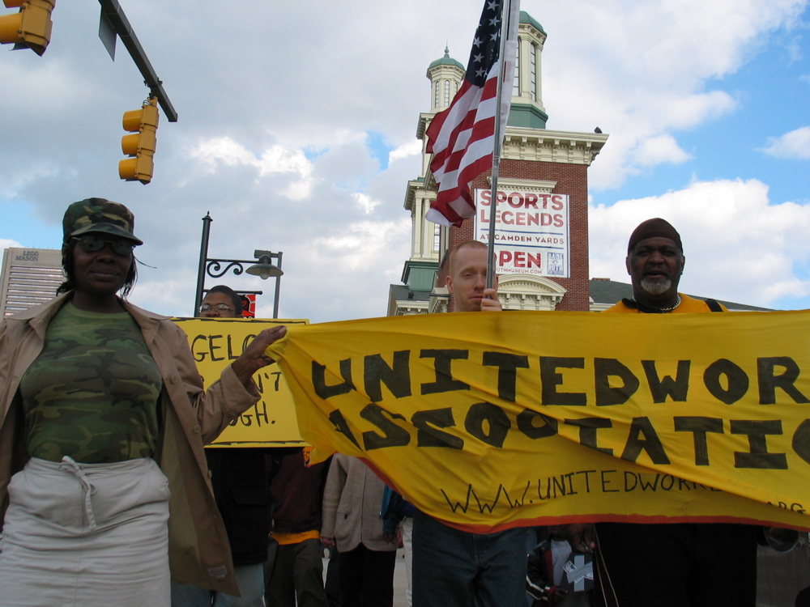

Stand with the cleaners of Camden Yards for economic justice and human rights. In 2003 Orioles owner Peter Angelos made and broke a promise to meet the cleaners’ demand of an above-poverty wage (Baltimore City Living Wage) for the Camden Cleaners. Stand up and demand that Angelos and the Orioles honor his word and stop profiting from poverty.

Get on the bus from Pittsburgh to Baltimore for the FREEDOM FROM POVERTY MARCH June 23rd and 24th.

The Anti-Sweatshop Pirates of Pittsburgh have declared Peter Angelos the only UNWELCOME visitor during the 2006 All Star Game at PNC Park.

Join us on Roberto Clemente Bridge and welcome the Camdem Yards Cleaning Crew to the City of Champions on July 11, 2006 – www.UnitedWorkers.org
PROUD TO BE A PITTSBURGHER
on July 11th, 2006

Thank you to the Pittsburgh City Council for hosting a sweatshop hearing in council chambers on January 31, 2005 and considering a revised anti-sweatshop ordinance that will require companies that bid on city apparel contracts to disclose and investigate factory conditions.

Thank you Allegheny County Council for stopping the City and County procurement departments until both the city and the county rise up to this region’s high standards for workers’ rights.

Thank you Governor Ed Rendell for the March 2004 Anti- Sweatshop Executive Order that prohibits the purchase of apparel from sweatshops. Please, now join the SweatFree Procurement Consortium’s Governor’s Coalition.

Thank you Duquesne University for co-sponsoring the National Garment Workers Federation of Bangladesh at Freedom Corner on October 16, 2004.

Thank you Carnegie Mellon University for having a model anti- sweatshop committee that worked together to decide to investigate apparel industry conditions and committing to full public disclosure of factory locations and independent monitoring of factory conditions.

IT’S A CIVIL RIGHTS BRIDGE to the FLOOR OF THE GLOBAL SWEATSHOP

Our community’s high standard for workers’ rights is clear.

And at the 2006 ALL STAR GAME – the Pittsburgh Pirates Baseball Club is stepping up to bat with the workers who sew the Pirates and All Star logo apparel.

No Sweatshops Bucco!
.
YOU CAN BE AN ANTI-
SWEATSHOP PIRATE, TOO!

The Anti-Sweatshop Pirates of Pittsburgh know that the future of our city, jobs, and peace, are connected to people in other parts of the world. We are sending an empowering message to people in other parts of the world that the people in Pittsburgh care about them and are invested in their ability to freely exercise their rights.

We tell workers in other parts of the world WHY we care about their struggle and about our own struggles for jobs and civil rights.

Who are the Anti-Sweatshop Pirates of Pittsburgh? We are organizers for and supporters of the Pittsburgh Anti-Sweatshop Community Alliance (PASCA). We are a project of Azania Heritage International at the Thomas Merton Center. We celebrate Steve Biko Day.

Our members are represented on the board of SweatFree Communities - an international coalition of apparel industry workers and their advocates - where we discuss how to use procurement dollars and licensing agreement to protect workers’ rights and support labor union organizing. Check out www.sweatfree.org

- LEARN MORE ABOUT SWEATSHOPS
- CONTACT US
- HOST MAJOR LEAGUE SWEATSHOP EDUCATIONAL EVENTS
- BE THE CIVIL RIGHTS BRIDGE BETWEEN PITTSBURGH AND THE WIDE, WIDE WORLD OF SWEATSHOPS ON JULY 11, 2006
Pittsburgh Anti-Sweatshop
Community Alliance
c/o Azania Heritage International @TMC
5125 Penn Ave
Pittsburgh, PA 15224

nosweatshopsbucco@yahoo.com

